
DEPARTMENT OF CSE
PROJECT ABSTRACT SUBMISSION
COURSE: SOA PROGRAMMING AND MICROSERVICES– (24SDCS03) A.Y. 2026 - 2027
TITLE OF THE PROJECT
S. No. | University ID | Name
1 | 2420030055 | A. Lahari
2 | 2420030132 | P. Priyanka
3 | 2420030410 | P. Sreehitha
Name of the Guide |  | Neelima Gogineni

Abstract:
Phishing is a major cybersecurity threat in which attackers use fraudulent emails, websites, URLs, and messages to deceive users and obtain sensitive information such as login credentials, financial information, and personal data. Traditional phishing detection techniques mainly depend on predefined rules, blacklists, and previously identified attack patterns. These approaches may have limitations when dealing with newly generated or evolving phishing attacks.

The proposed AI-Based Phishing Detection & Response Agent aims to provide an intelligent approach for detecting and responding to potential phishing threats. The system will accept suspicious URLs or email/message content as input and perform preprocessing and feature extraction to identify relevant phishing characteristics. Machine learning techniques will then be used to classify the input as phishing or legitimate.

In addition to detection, the proposed system will generate a risk score to indicate the severity of the detected threat. Based on the classification and risk level, the response agent will provide an appropriate recommendation such as alerting the user, blocking the suspicious content, or reporting the threat. This combines phishing detection, risk assessment, and response assistance within a single system.
The performance of the proposed model will be evaluated using metrics such as accuracy, precision, recall, F1-score, and false-positive rate. The project aims to improve automated phishing detection and provide users with faster and more informed responses to potential phishing attacks.

Project Architecture/Project Overview:

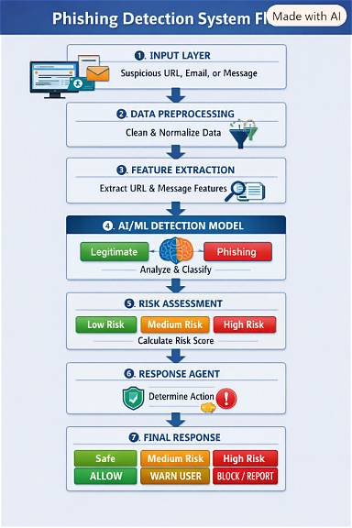

Basic flow of our project:
URL / Email / Message
↓
Preprocessing
↓
Feature Extraction
↓
AI/ML Model
↓
Phishing Detection
↓
Risk Score
↓
Response Agent
↓
Alert / Allow / Block / Report

